Pizza Sales SQL queries

A. KPI’s

1. **Total Revenue:**

SELECT SUM(total_price) AS Total_revenue from pizza_sales

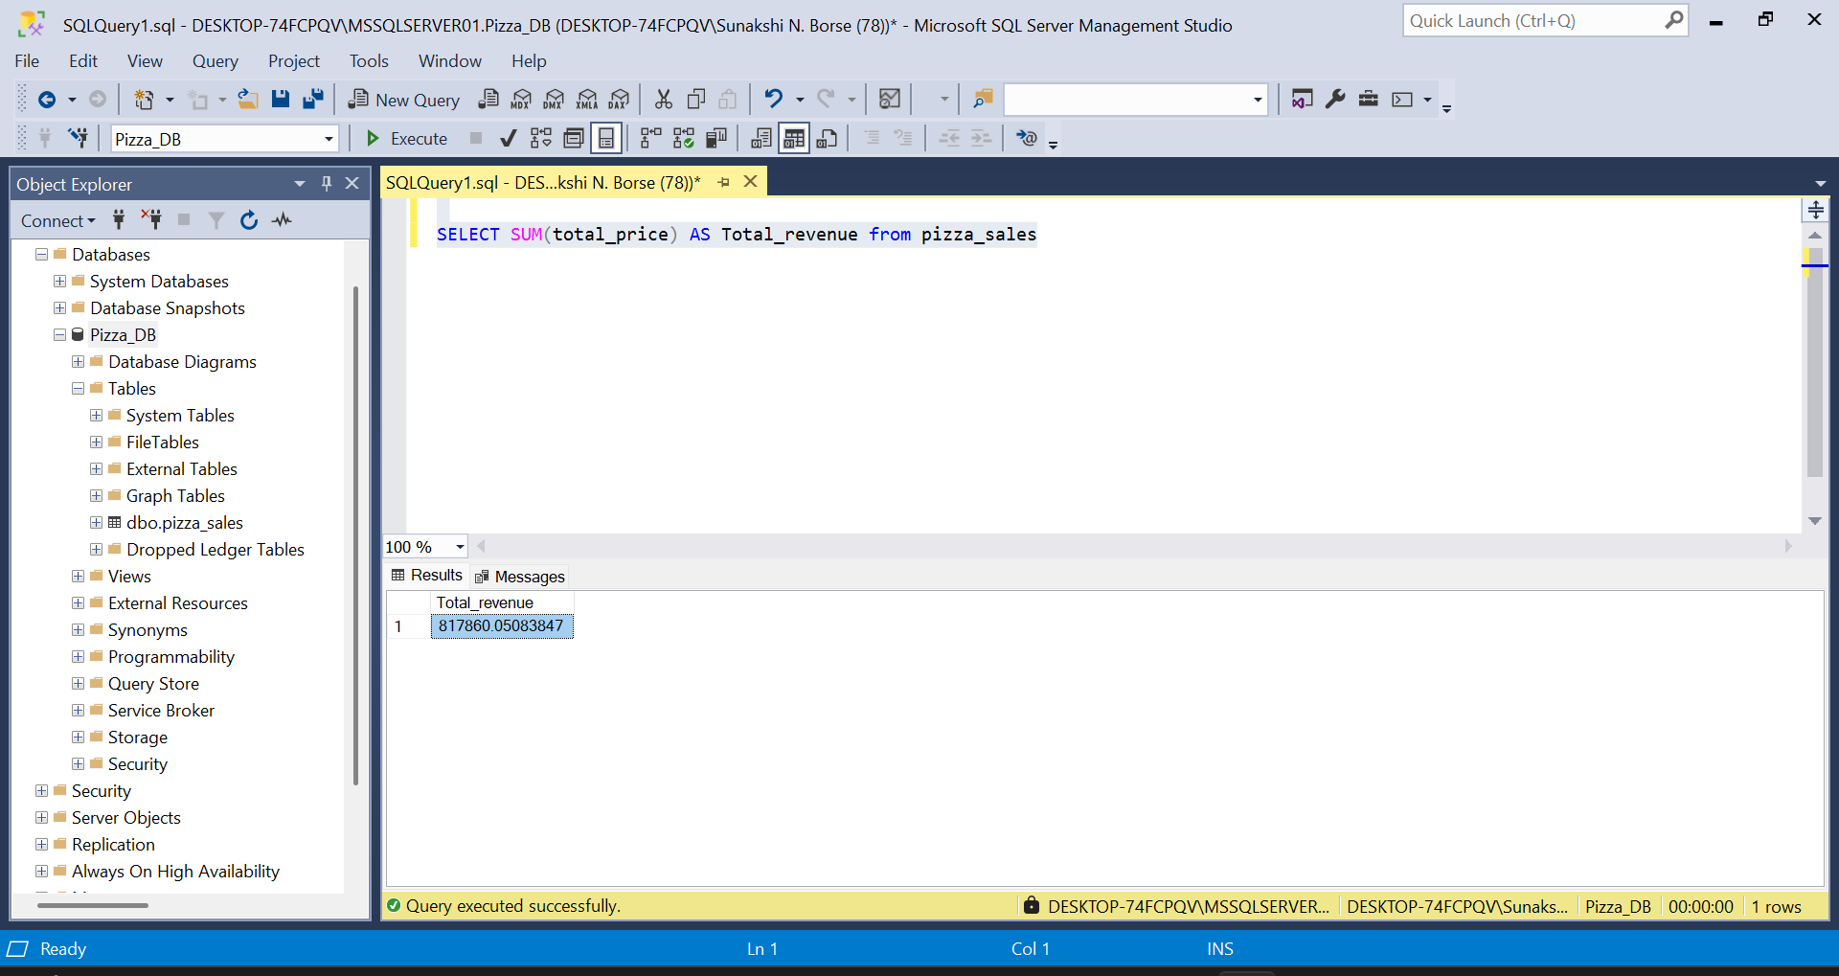

1. **Average Order Value:**

SELECT SUM (total_price) / COUNT(DISTINCT order_id) AS avg_order_value from pizza_sales

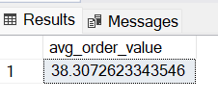

1. **Total pizza sold:**

SELECT SUM(quantity) AS total_pizza_sold from pizza_sales

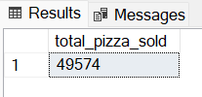

1. **Total orders:**

SELECT COUNT(DISTINCT order_id) AS total_orders from pizza_sales

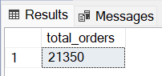

1. **Average pizza per order:**

SELECT CAST(CAST(SUM(quantity) AS DECIMAL(10,2)) /

CAST(COUNT(DISTINCT order_id) AS DECIMAL (10,2)) AS DECIMAL (10,2)) AS avg_pizza_per_order from pizza_sales

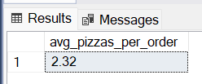

1. **Daily trends for total orders:**

SELECT DATENAME(DW, order_date) as order_day, COUNT(DISTINCT order_id) as total_orders

from pizza_sales

GROUP BY DATENAME(DW, order_date)

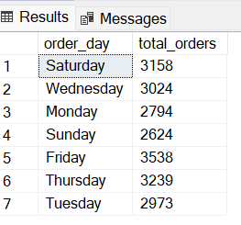

1. **Monthly trends for total orders:**

SELECT DATENAME(MONTH, order_date) as Month_Name, COUNT(DISTINCT order_id) as total_orders

from pizza_sales

GROUP BY DATENAME(MONTH, order_date) ORDER BY total_orders DESC

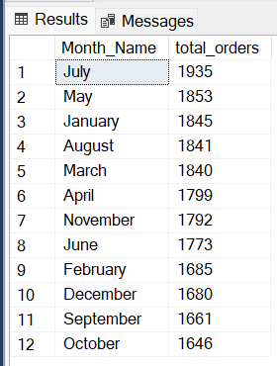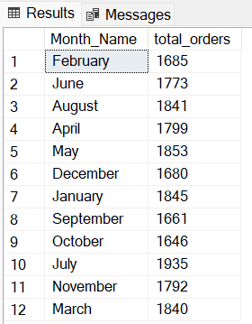

1. **Percentage of sales by pizza category:**

SELECT pizza_category, SUM(total_price) as total_sales, SUM(total_price) * 100 / (SELECT sum(total_price) from pizza_sales) AS PCT

from pizza_sales

WHERE MONTH(order_date) = 1

GROUP BY pizza_category

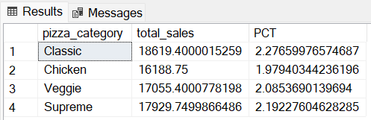

1. **Percentage of sales by pizza size:**

SELECT pizza_size, SUM(total_price) as total_sales, SUM(total_price) * 100 / (SELECT sum(total_price) from pizza_sales WHERE DATEPART(quarter, order_date) = 1) AS PCT

from pizza_sales

WHERE DATEPART(quarter, order_date) = 1

GROUP BY pizza_size

ORDER BY PCT DESC

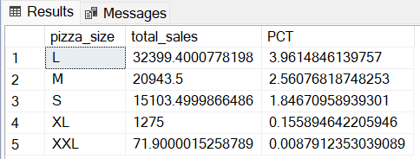

1. **Top 5 best sellers by revenue, total quantity and total orders.**

SELECT TOP 5 pizza_name, SUM(total_price) as total_revenue from pizza_sales

GROUP BY pizza_name

ORDER BY total_revenue DESC

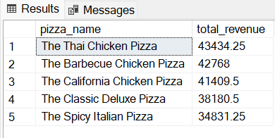

SELECT TOP 5 pizza_name, SUM(quantity) as total_quantity from pizza_sales

GROUP BY pizza_name

ORDER BY total_quantity desc

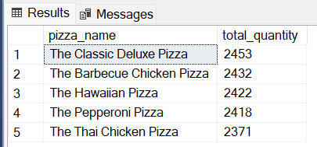

SELECT TOP 5 pizza_name, COUNT(DISTINCT order_id) as total_orders from pizza_sales

GROUP BY pizza_name

ORDER BY total_orders desc

